An Active Shooter Preparedness Program for Vermonters
Bennington County Trainings 2022
Webinar 35-minute video available at no cost: reach out to 802-447-6401
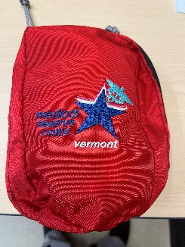
(Free Trauma Kit for those organizations who complete webinar training)
Survivermont! is a program that was created to educate and empower Vermonters with (tried and true) information about what they can do to protect themselves and their family members in the event that they are confronted with an Active Shooter or Violent Threat situation, regardless of where the incident occurs.

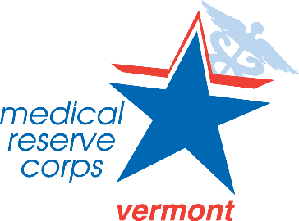
This program combines 3 easy-to-remember concepts from established national public safety programs: See Something, Say Something; Run, Hide and Fight; and Stop the Bleed. Created by Partners at:
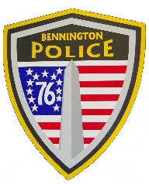
Bennington Police Department
Bennington Rescue Squad
Southwestern Vermont Medical Center
The Vermont Department of Health
Medical Reserve Corps of SW Vermont

As Vermonters, we pride ourselves on our self-sufficiency, our resilience, and especially our willingness to help others in times of need.

Together, we can help! survivermont.org

